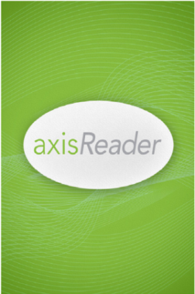
Introducing axisReader!
Baker & Taylor has now released its dedicated app for iOS, Android and NOOK device users — axisReader — which creates a direct, streamlined and intuitive user experience for your patrons using Axis 360!
With axisReader, patrons are able to create a permanent link between their device and your library's Axis 360 collection, and can checkout, download and read ebooks in one simple set of steps. This complete in-app experience will be welcomed by your users as well as library staff.
The axisReader app is available via the Apple App Store, Google Play and links in the App Zone of the mobile Axis 360 websites. Also, now with the opening of the entire Google Play app store for users of NOOK tablets, NOOK owners can load and use axisReader on their favorite ereading device.
AxisReader provides the ideal ereading environment your patrons have been requesting. AxisReader is great for recreational and required reading – in the car, on the train, by the pool, anywhere your patrons want to read! AxisReader also provides built in tools such as highlighting, bookmarks and dictionary lookup.
The axisReader app delivers on-the-go access to your library for all mobile device users. And in addition to direct download and reading of ebooks in EPUB and PDF formats, the axisReader supports discovery and checkout of all the content formats in your digital collection. The includes Blio ebooks and Acoustik Audiobooks for easy cloud access and enjoyment in those powerful applications.

