Get Started Using Axis 360 & Blio on Your iOS Device Today!

Visit the App Zone at www.demo.axis360.baker-taylor.com. Select Blio.
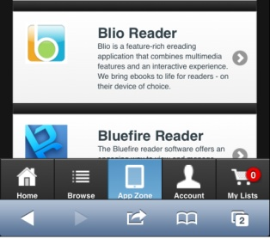

Install Blio.
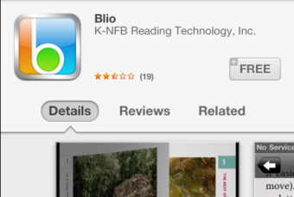

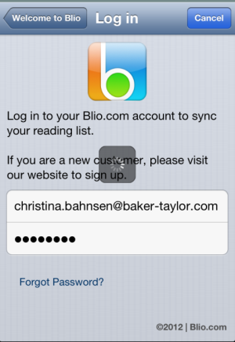
Open Blio & Register/Log In.
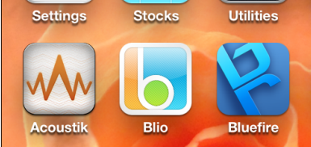

Search for eBooks at www.demo.axis360.baker-taylor.com.
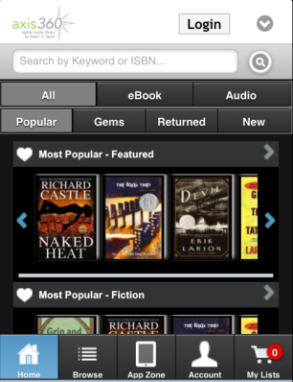

Select the Blio format.
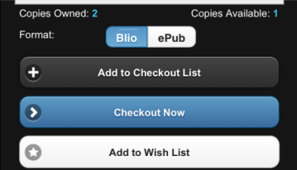
Log in & Confirm Checkout.

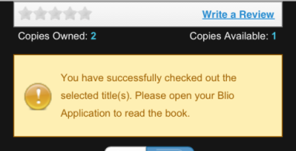
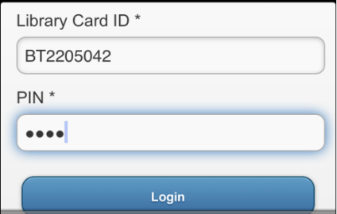

Open Blio & Begin Reading.
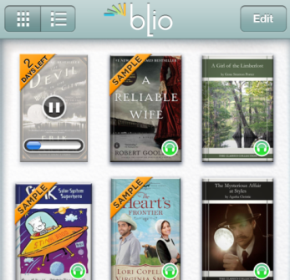

Using tools in Blio

Enter a bookmark.
Return to Library.
Click, hold and then drag to highlight text.
Adjust font size, review bookmarks, and listen to the audio track.
Check progress in book; move easily through pages.

