**Get Started Using Axis 360 & Blio on your Android Device Today!**

Visit the App Zone at [www.demo.axis360.baker-taylor.com](http://www.demo.axis360.baker-taylor.com). Select Blio.

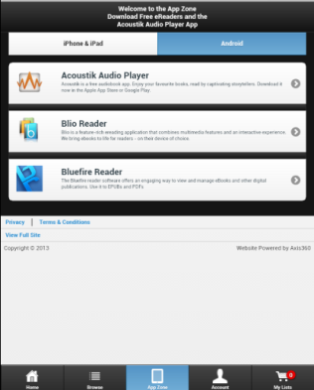

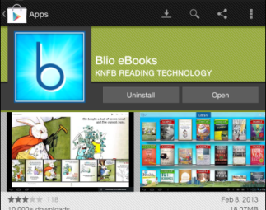Install Blio.

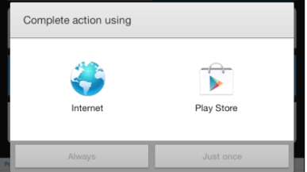

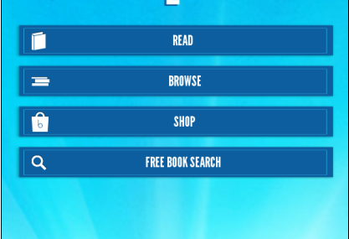Open Blio & Register/Log in.

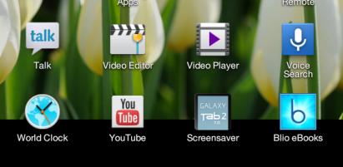

Search for eBooks at [www.demo.axis360.baker-taylor.com](http://www.demo.axis360.baker-taylor.com).

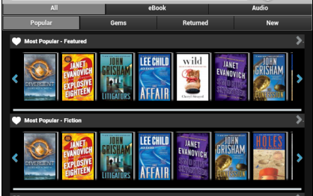

Select the Blio format.

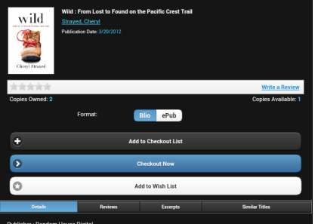

Log in & Confirm Checkout.

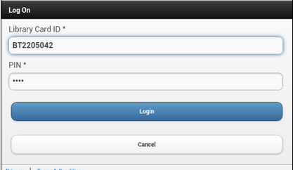

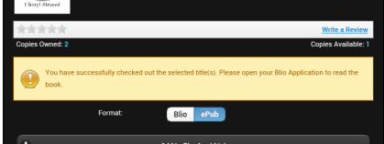

Open Blio & Begin Reading.

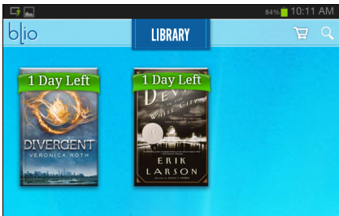

Using tools in Blio.



Menu options to change font, search and enter bookmarks.

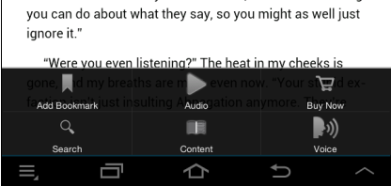

Tap the screen for additional menu options; audio, content, access to bookmarks and more.

Check your progress in the book; move easily through the pages.