LOADING BLIO ON THE 1stGEN KINDLE FIRE (non HD)
NOTE: These instructions were written and screen shots taken while browsing on a First Generation Kindle Fire with the original (v1.0) Silk Browser. If your experience is different from the following, then you may have a 2ndGen Kindle Fire, which requires a different set of instructions.
To start the process, please make sure you are on the Home Screen. The HOME icon is in the lower left and looks like a house.
In the upper right of the screen, you will see the settings icon. It looks like a star burst or circular gear. Tap this.
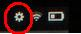
Then select MORE (the PLUS icon).
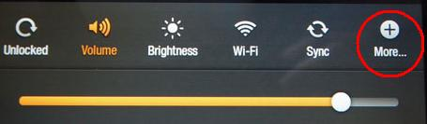
You should then see a list of options. Select DEVICE. (You may need to scroll the screen up to find it.)
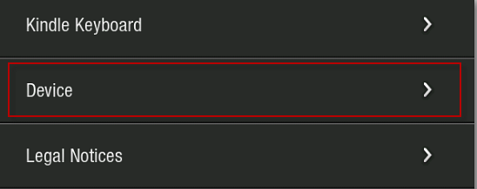
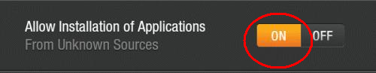
Then select ON to “Allow Installation of Applications From Unknown Sources.”

Please remember to set this option back to “off” when finished.
----------------------------------------
Next it is time to download the app. Go back to the Fire’s home screen (HOUSE icon, lower left). Then tap the WEB tab.
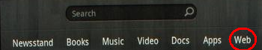
Type in the following URL: http://bits.blioreader.com/update
When the page loads you will see several file options. Choose the link to the LATEST APK FILE…named something like KNFB Blio 3.1.1 PROD.apk. (If you see a link for 2.5.1, 3.0.1 or 3.0.3, it is a previous version.)
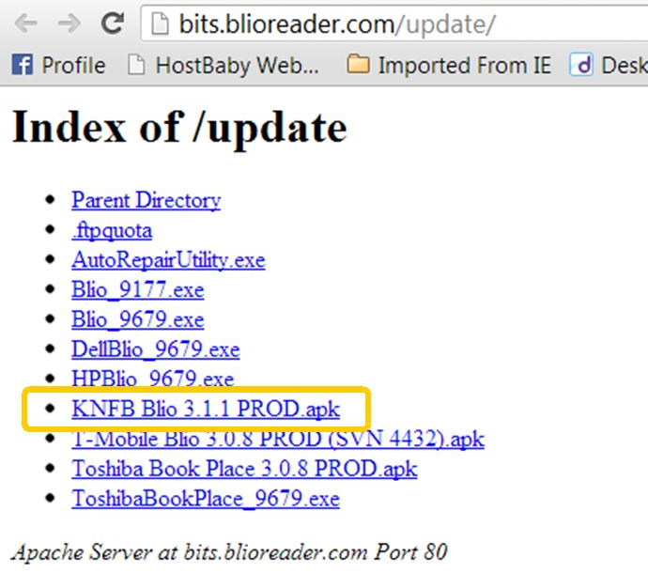
After you do this, you should see a number in the upper left of the Kindle Fire. Tap the number.
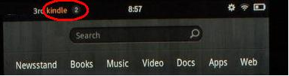
Then you should see “KNFB Blio 3.1.1 PROD.apk downloading”.
Once the orange progress bar finishes, the download is complete.
Tap “KNFB Blio 3.1.1 PROD.apk Download Complete.”
The next screen will list the permissions the app requires. Tap INSTALL in the grey area under the permissions.
You should then see a line that says “Installing.”
After installing, you should see INSTALL COMPLETE. Tap DONE at the bottom of the screen.
Go back to the Home Screen.
You should now see the blue icon for Blio in your carousel.
Tapping this icon will launch the Blio app.
You may also select the APPS tab on the Home Screen and you should also see the Blio icon, under the DEVICE tab.
----------------------------------------
Once you LAUNCH the Blio app, you’ll be prompted to LOGIN with your Blio ID and PASSWORD.*

Once logged in, Blio will synch with your Book Shelf and bring in purchased titles as well as titles borrowed from Axis 360/your library.*

*For more info on logging into Blio, registering for a Blio account, and borrowing Blio-compatible eBooks from your library, go to your library contact.

Latest Update, 8-20-13, RF/COM

