axisReader Sideload on the Kindle Fire (non-HD)

The axisReader app, while not specifically found in the Kindle app store, is in the Android Google Play app store. The axisReader app can safely be installed on the Kindle Fire as a SIDELOAD. Following is one set of detailed instructions for this. It is a multi-step process. NOTE: You will need to have a WiFi connection for your Kindle Fire to complete this install.

----------------------------------------

STEP 1: SETTINGS

- To start the process, please make sure you are on the HOME SCREEN. (The home button is the option in the lower left that looks like a house.)
- In the upper right of the screen, you will see the QUICK SETTINGS icon. It looks like a star burst or circular gear. Tap this icon.

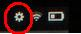

- Select the option that says “MORE”.

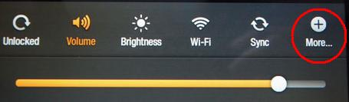

- In the next screen, you should see a list of options. Select DEVICE. (Please note that you may need to scroll the screen up to find it.)

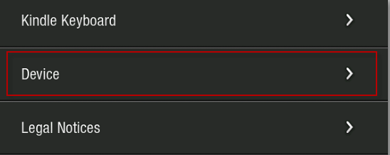

- In the next screen, select ON for the option to “Allow Installation of Applications for Unknown Sources.”

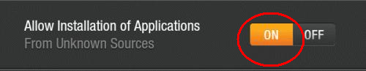

Please remember to set this option back to OFF when finished.

----------------------------------------

STEP 2: PC DOWNLOAD

- Go to http://apps.goodereader.com/android-apps/e-reader-apps/?did=14200 on the PC
- (Attempting to download directly on the Fire only results in a PHP file, not an APK.)
- Tap the orange DOWNLOAD button (left side of page)

- Go to wherever your download APK file has been saved. (Possibly save as a file link at the bottom of the screen, or in the MY DOWNLOADS folder on your C drive.)
- The file should be named something like “axisReader 1.0.apk”.
- If you can’t find it, then type “axisReader” in your main search box.
- Once located, you may want to transfer it to a more commonly accessed location, like your desktop.
- Minimize that window on your PC. It will be used later.

----------------------------------------

STEP 3: TETHER

- Tether your Kindle Fire to your PC, using a USB to Micro-USB cable.
- Note: This cable is optional and not included with the Kindle Fire upon purchase.
- A link to one is: http://www.amazon.com/USB-Micro-Cable-White/dp/B006BGZJJ4/ref=pd_sim_kinh_2

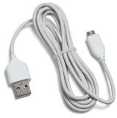

- Once your PC has detected the Fire, go to MY COMPUTER>KINDLE FIRE (may be indicated as the D, E, etc drive)>Downloads Folder.
- Open the previously minimized location of the axisReader APK file download.
- Drag the previously saved APK file from there to the Downloads Folder of the Kindle Fire.

----------------------------------------

STEP 4: FILE EXPLORER

- Now open your Kindle Fire.
- From the HOME screen, tap on APPS.
- Go to the STORE
- Search for ES FILE EXPLORER

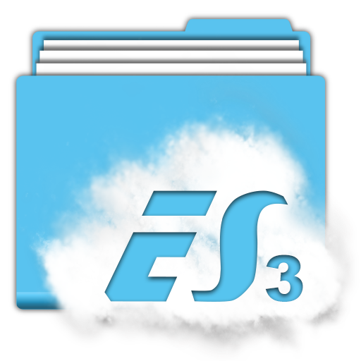

- Install it. It is free.
(You may also do this on your PC.)

----------------------------------------

STEP 5: INSTALL THE APP

- After installing go back to the HOME SCREEN on your Fire.
- Tap the QUICK SETTINGS icon (the toothed gear at the top).
- Tap SYNC

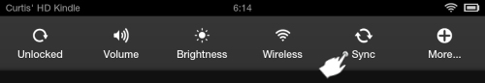

- Now from the HOME screen, go to APPS>DEVICE and find the ES FILE EXPLORER icon.
- Open it and locate the DOWNLOADS folder.
- Open it and find the APK file that you dropped there, earlier.
- Tap it to install.
- The axisReader app should begin installing on your Kindle Fire.
- If you notice later, in the ES File Manager folder list, an axisReader folder is now there.
- Upon successful installation (up to a few minutes) you’ll be asked if you want to OPEN or DO MORE.
- If you tap OPEN, the axisReader app will open to the initial login page where you’ll authorize your device with your Adobe ID.

Latest Update 6-27-13 RF/COM

